**OREM 7301/5301 – Fall 2022**

**Final Project Report**

**-**

**Robotic Transformer**

*Prepared For*

***Prof. Brett Schulman***



*Prepared By*

***Hareish Raghupathy***

*Date Submitted: 12/10/2022*

**Table Of Contents**

1. *Business / Mission Analysis*
   1. Opportunity
   2. Solution and Alternatives
   3. Major Stakeholders
   4. Operational Environment
   5. Life Cycle
   6. Business Requirement
2. *Stakeholder Needs and Requirement Definition Process*
   1. Other Stakeholders
   2. Stakeholder Requirements
3. *System Requirements*
   1. Requirements
   2. Traceability
   3. Requirement for Verification and Validation (Any 5)
   4. Technical Performance Measures
4. *Architecture Definition*
5. *Design Definition*
6. *System Analysis*
7. *Implementation*
8. *Integration*
9. *Verification*
10. *Transition*
11. *Validation*
12. *Operation*
13. *Maintenance & Support*
14. *Disposal*
15. ***Business / Mission Analysis***
    1. **Opportunity**

In the modern world, there is a huge leap in terms of robotics and automation. It is the same when it comes to automobile industries as they are working towards the implementation of self-driving cars using technologies from robots. The key opportunity is the creation of a new entity which is essentially a transformer ideal for the tech ecosystem that we currently live in. It can prove to be one solution to accomplish any need a person could have from having a robot assistant that can aid in multiple things while allowing it to turn it into an automobile to facilitate autonomous transport as well.

A Sample idea of the system is shown below,

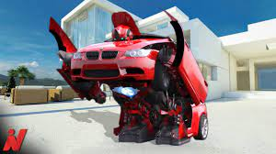

Fig 1: Transformation(Source: Google Images)

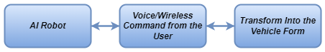

Fig 2: Command Process

The transformation or any action is only based only on the command given by the user within the accepted criteria. The neural network of the system has the ability to learn new things but is restricted to implement them unless authorized by the admin to ensure safety. The command chain would look like this:

The system cannot transform into any shape given the current technology and resources available. Therefore, they are configured to a prestructured compatible automobile before the usage.

* 1. **Solution and Alternatives**

We have seen groundbreaking innovations and improvements in the fields of AI, machine learning,robotics along with the computational capacity of their mechanisms over the recent years.

There are AI enabled cars that can transport people autonomously, there are pure performance cars that can transport people faster and there are also personal robots being used currently for various tasks

Yet, there is no current technology that can perform the function that this proposed system would accomplish. It is a revolution in terms of the integration as it brings transport and personal assistance with robotic technology to next levels.

The world has changed, people now carry an entity like a smart phone for all their needs instead of carrying a separate piece of tech for every need. A smart phone has replaced the need for carrying physical documents, wallets and watches. The solution for every separate problem exists but a single solution for all the problems does not. The key to designing this system is the sole integration of the idea of transport and robotics in order to provide the ultimate assistant that can do every task for the people under their command. Since the system operates on electricity it also brings quality of life improvements as well as reduction of running cost in the longer run for the users.

* 1. **Major Stakeholders**

The Stakeholder of the following system will include:

* Robotic Industry
* Automobile Manufacturers
* Automation Industry
* Electrictricity Suppliers
* Government and Regulatory Agencies
* Insurance Companies
* Customers
* Users

* 1. **Operational Environment**

The operational environment for the system is diverse ranging from inside or outside the houses to small streets and national freeways. It mostly encompasses the roadways and housing areas unless specifically used for other useful purposes under regulatory norms and controls. This

* 1. **Life Cycle**

The system involves major components like the robotic neural network, engine, physical body and control unit. These are enabled by software controls provided by the manufacturer to the user with appropriate restrictions for safety. The system can be made a more portable one by going with a smaller version (For example: The transport would be enabled via a two wheeler instead of a four wheeler). It must always be made sure that the current system does not technically interfere with the progress of any other system in its vicinity.

Therefore, we can categorize the system based on three developmental cycles:

* Robotic Neural Network
* Engine and Physical Structure
* Control unit

The generic representation of the system life cycle is given below:

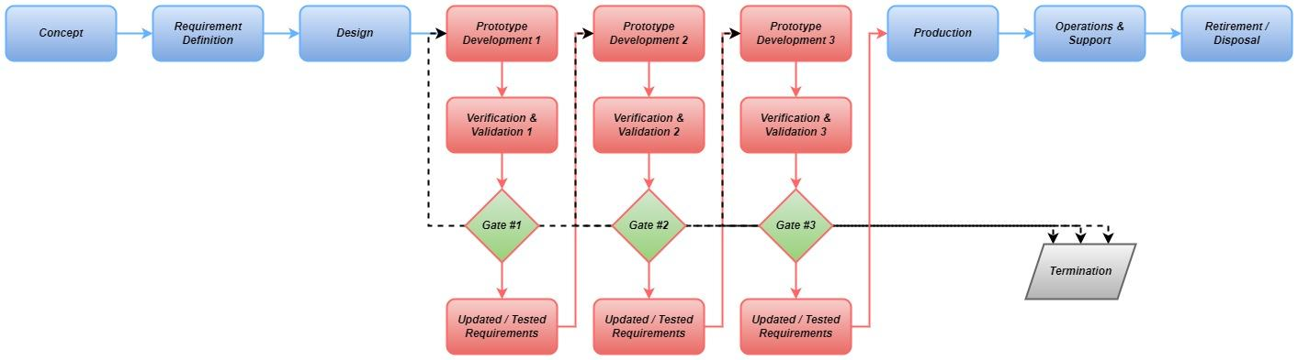

Fig 3: Life Cycle of the System

* 1. **Business Requirement**

BR1 - The system shall enable integration of autonomous travel & assistance in the current market.

BR2 - The system shall enable the revolution in future travel solutions using battery powered neurally driven engines.

BR3 - This system shall reduce the carbon footprint as one structure does the work of two technology figures.

BR 4 - The system shall have the ability to learn newer functions via AI and ML

BR 5 - This system shall give people the ability to use AI robots for day to day tasks in a miniature detachable system.

BR 6 - This system shall enable portability and safety of a robotic vehicle wherever the user goes.

1. ***Stakeholder Needs and Requirement Definition Process***
   1. **Other Stakeholders**

* Manufacturers
* Technicians
* Support & Service Facilities
* Adjacent Industries like Electric Power Plants, AI, Automation, Robotics, EV manufacturers etc
* Service Providers and its Admins
  1. **Stakeholder Requirements**

SR1 - Government should mandate all road and safety regulations required for the functioning of the system.

SR2 - All functional commands given to the system will be only from the user and admin access is required for the ones categorized as harmful/ dangerous.

SR3 - The machine should be able to function for at least 5 days on a single charge while being able to recharge itself automatically whenever there is an opportunity.

SR4 - The total time taken for the transformation shall be less than 1 minute.

SR5 - The system shall aid the owner/user in day to day tasks with the help of internet and structural capabilities.

SR6 - The robot shall be able to detach its core system along with primary limbs to assist in small environment tasks.

1. ***System Requirements***
   1. **Requirements**

The Requirements are categorized under various functional groups as shown below:

* Physical
* System Operation Interface
* Robotic
* Automotive
* Control Unit
* Maintenance

Physical:

R1 - The total Width of the transformed robot shall be less than 75 inches.

R2 - The total Length of the transformed robot shall be less than 185 inches.

R3 - The total Height of the transformed robot shall be less than 55 inches.

R4 - The overall Weight of the robot shall be less than 2100 lbs.

R5 - The material used of the body shall be corrosion resistant.

R6 - The body shall be resistant to temperatures in the range of -10°C to 65°C.

R7 - The robot shall only use battery power for functioning and transport while retaining the charge for at least 120 hours.

R8 - The system shall be charged by the default 110 to 220V AC outlet via SAE J1772 connector.

R9 - All the joints of the system shall be made of hydraulics to enable self balancing during transformation.

R10 - The system shall be agile in its movement taking <3 seconds to change direction in robot mode.

System Control Unit:

R11 - The system shall communicate with the user via voice and wireless commands given through the smartphone.

R12 - There shall be an application to control the functioning of the robot.

R13 - The support and maintenance admin assigned for the system shall have overriding controls over the system to ensure its operation within legal constraints.

R14 - The system shall recharge itself automatically if there is a charging port nearby after authorization from the user.

R15 - Any restricted commands given by the user shall be authenticated by the admin.

Robotic:

R16 - The response time for command reception must be less than 0.5 milliseconds.

R17 - The robotic circuitry shall contain a secondary fuse unit to ensure safety and reliability in case of a failure.

R18 - The system shall not automatically do an action based on its AI database unless approved by the user.

R19 - The system shall use self-balancing motors to maintain balance when tried to be knocked off its feet.

R20 - Data storage in the neural network shall happen instantaneously using the encoded machine learning algorithm.

Automotive:

R21 - The total horsepower output of the system shall be atleast 200bhp.

R22 - The system shall have two seats available when transformed.

R23 - The system shall provide an efficiency of at least 25 kWh/100 miles.

R24 - The system shall accelerate from 0 to 100 in under 7 seconds.

R25 - The system shall have a top speed of at least 120mph.

UI:

R26 - The system shall be controlled through an application wirelessly.

R27 - The system shall always be connected to the application.

R28 - The user interface commands shall be categorized based on the type of task given.

R29 - Any Command involving safety and security shall be performed only after authentication from the admin

R30 - The application shall support Android OS, iOS, Windows, MacOS and Linux UI.

Maintenance:

R31 - The system shall support wireless software update for maintenance purposes.

R32 - The total down time of the system during the software updates shall not exceed 15 minutes.

R33 - The mean time between maintenance shall be once in every 3 months.

R34 - The admin shall provide the system health updates every week.

R35 - Any failure or high probability of failure will immediately be reported to the user through alerts via message or call.

* 1. **Traceability**

| Requirement | Traceability |
| --- | --- |
| R1 | OE |
| R2 | OE |
| R3 | OE |
| R4 | OE,BUSINESS |
| R5 | OE,BUSINESS,STAKEHOLDER |
| R6 | OE,BUSINESS,STAKEHOLDER |
| R7 | OE,STAKEHOLDER |
| R8 | OE,STAKEHOLDER |
| R9 | OE |
| R10 | OE |
| R11 | STAKEHOLDER |
| R12 | OE,STAKEHOLDER |
| R13 | STAKEHOLDER,BUSINESS,MISSION |
| R14 | OE,STAKEHOLDER |
| R15 | MISSION,BUSINESS,STAKEHOLDER |
| R16 | STAKEHOLDER |
| R17 | STAKEHOLDER |
| R18 | STAKEHOLDER |
| R19 | OE,STAKEHOLDER |
| R20 | STAKEHOLDER,MISSION |
| R21 | STAKEHOLDER |
| R22 | STAKEHOLDER |
| R23 | OE,STAKEHOLDER |
| R24 | OE,STAKEHOLDER |
| R25 | OE,STAKEHOLDER |
| R26 | STAKEHOLDER |
| R27 | STAKEHOLDER |
| R28 | STAKEHOLDER, |
| R29 | BUSINESS,STAKEHOLDER,MISSION |
| R30 | OE,STAKEHOLDER |
| R31 | OE,STAKEHOLDER |
| R32 | STAKEHOLDER |
| R33 | STAKEHOLDER, |
| R34 | STAKEHOLDER |
| R35 | STAKEHOLDER,MISSION,BUSINESS |
|  |  |

* 1. **Requirement for Verification and Validation(Any 5)**

**R23** [The system shall provide an efficiency of at least 25 kWh/100 miles]:

* Verify the simulated power and range results
* Test the vehicle mode in track for practical range
* Find out the factors affecting the range and validate them
* Test the vehicle in normal road to simulate the real world efficiency
* The test is successful considering the range is > 25kWh/100 miles.

**R7** [The robot shall only use battery power for functioning and transport while retaining the charge for at least 120 hours]

* Use a dyno to test run the robot in both modes
* Record the timing until shutdown
* Now test run the robot in the operational environment and check the external factor effects on the battery
* Verify the initial timing, test run timing and claimed timing
* Repeat the cycle to test for degradation
* End the test if the verification succeeds.

**R19** [The system shall use self-balancing motors to maintain balance when tried to be knocked off its feet]

* Check the motors’ weight capacity
* Do an external force testing in a controlled environment
* Conduct the force test in irregular conditions
* Check if the tested values for each condition matches with the claimed figures
* Push the motor further to study its threshold limits
* Finish the test if the values match the required figures for the robot's weight and dimension.

**R32** [The total down time of the system during the software updates shall not exceed 15 minutes]

* Ready the servers to provide sample software upgrade
* Connect the robot to the servers
* Check the internet speed
* Initiate the transfer(depends on internet) and installation(constant time)
* Calculate the time take for both separately
* Allow the system to complete the update and restart it
* Measure the total time taken to install, restart and transfer
* Verify it against the claimed down time and complete the test if the figure matches.

**R11** [The system shall communicate with the user via voice and wireless commands given through the smartphone]

* First check the voice identification and reception through the speaker and mic system built in the robot
* Use different voices to test for identification / communication errors
* Add disturbances to the voice to check the noise cancellation and voice filtration functions
* Now, connect the system to an Android or iOS device
* Operate the robot using the command given via the mobile wirelessly
* Check the response to an unidentified command to check the response
* Give a dangerous command blocked by the admin to analyze the output of the robot
* Repeat the above for multiple inputs as it concerns safety factors
* Verify the results against the anticipated results column
* Finish the testing phase if the outputs match the expectations.
  1. **Technical Performance Measures**

Three key TPMs that should be monitored in the system are:

* Measure of Transformational Efficiency:

This is the factor key to the main concept of the transformer. It ensures the successful transformation of all the hardware and control systems in the body. This can be calculated by taking the quality of transformation, speed, efficiency and friction in the gear into consideration. All these parameters are to be entered in the respective calculating model designed to obtain the quantified value to monitor it against the baseline.

* Measure of Response Time:

This is another factor which decides the quality of communication between the user and the machine ultimately contributing directly to the user experience by maintaining responsiveness of the system. To maintain the < 0.5 ms neural delay, this has to be calculated and verified against the values stored in the database for every functional element of the system during any action or command.

* Measure of ML Model Reliability:

The ML learning model enables the AI integrated in the system to perform any action while referencing data stored from the cloud. The reliability of ML learning is to be monitored regularly against its optimal performance to feed in maximum information for the system to learn new technologies or functional methods. This learning is the driving factor to achieve the autonomous status for the robot in both the modes separately(Vehicle & Assistant Mode). Both the modes are to be tested and updated with respect to the specific conditions set for it in the control system.

1. ***Architecture Definition***

The Architectural/ Functional structure of the system is shown below for 3 levels with respect to the following elements:

* **Level 1** Functionality [Highest Functional Description of the System]

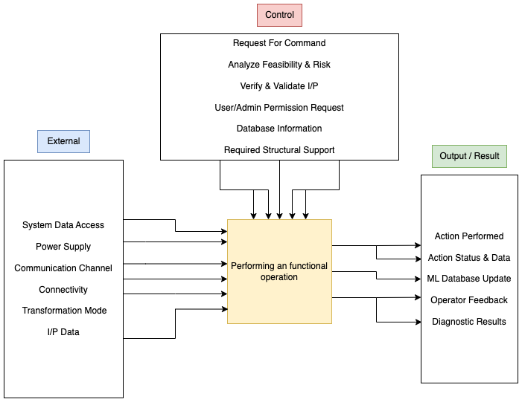

* **Level 2** Functionality [This takes the level 1 functions into the detailed spectral relationship between them]

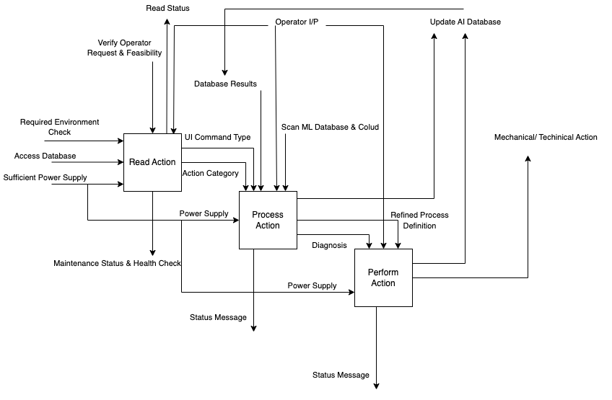

* **Level 3** Functionality [This is the elementary relationship between the details and functions mentioned in level 2]

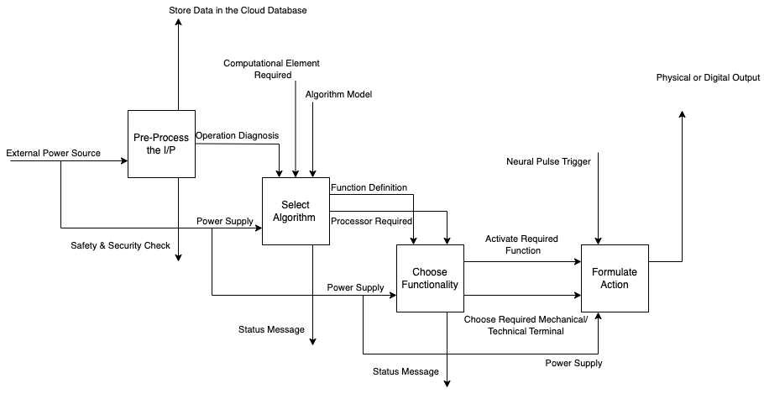

1. ***Design Definition***

The following diagram shows the product hierarchy of the system:

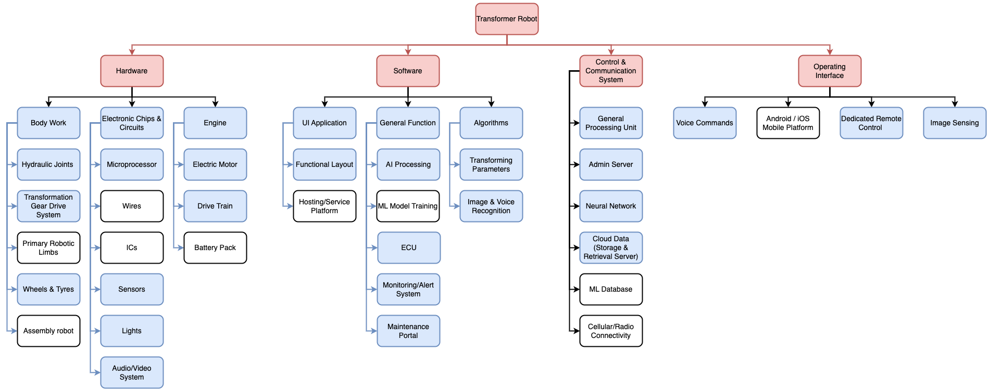

[**Note**: **Enablers** in the above diagram are mentioned in **White Boxes**]

Product Hierarchy Traceable To Requirements:

| Requirement | Traceability |
| --- | --- |
| R1 | Hardware |
| R2 | Hardware |
| R3 | Hardware |
| R4 | Hardware |
| R5 | Hardware |
| R6 | Hardware |
| R7 | Hardware |
| R8 | Hardware |
| R9 | Hardware |
| R10 | Hardware, Software |
| R11 | Control & Communication |
| R12 | Control & Communication, Operating Interface |
| R13 | Control & Communication |
| R14 | Control & Communication, Software |
| R15 | Control & Communication |
| R16 | Software |
| R17 | Software |
| R18 | Software |
| R19 | Software |
| R20 | Software |
| R21 | Hardware |
| R22 | Hardware |
| R23 | Hardware |
| R24 | Hardware |
| R25 | Hardware |
| R26 | Operating Interface |
| R27 | Operating Interface, Control & Communication System |
| R28 | Operating Interface, Control & Communication System |
| R29 | Control & Communication System |
| R30 | Operating Interface, Software |
| R31 | Software, Operating Interface |
| R32 | Software, Operating Interface |
| R33 | Hardware,Software |
| R34 | Software |
| R35 | Software |
|  |  |

1. ***System Analysis***

System analysis plays an important part in the system’s life cycle while providing various methodologies to understand the functioning of the system. The prototype stage for every major component used in the system facilitates the verification of the actual design, intended result and the actual result.

During that stage we generally use mathematical models and various other tools to validate the output of the design. This measures the performance and working characteristics of the product with respect to the functional requirements of the system.

In the latter phase after modifying and changing the system to match the requirements, it is then sent into further diagnosis and training to enable the internal AI and neural network to learn newer models for the required functions to enhance the performance. All the data stored and computed during this process is used to aid in the functioning of the robot enabling it to adapt to various environments. For instance, when the robot falls during this training phase it learns how not to fall and adds it to its cloud based library.

This process of training and testing to analyze the system result and behavior is similar to that of the verification stage. The key difference here is that this is done to develop the system whereas the actual testing and validation is done to evaluate the system against the main requirements and other safety or reliability related boundaries.

After a series of training and tests the three major subsystems are integrated and tested using the FMEA analysis to identify errors and rectify them. Several other tools are used to measure the automotive performance, neural capability, communication and connectivity etc.

1. ***Implementation***

The implementation phase generally uses a set of sequential methods to enable the development of the hardware, software and the control/connectivity platform of the system.

The hardware undergoes a rigorous physical and functional check to ensure it is capable enough to handle the tasks without failure.

The software usually goes through a number of different cycle tests to ensure it is error free for all the required scenarios. On identification of an error the softwares is updated immediately and recorded in the change documentation, this would especially be made easier when developed in an agile platform to make it more flexible for changes.

The communication/control system usually requires both the hardware and software to be completed to verify its correct working. Therefore, this is the last phase which finally verifies the whole working of the system from the uses.customer’s point of view. This phase can be modified as per the customer needs so as to provide a customized control over the product while contributing to its ease of use within the safety limits and norms.

Any feedback of failure modes with respect to the above mentioned subsystems are identified and immediately addressed to in this stage.

1. ***Integration***

Integration will be performed in parallel or in coordination with the Implementation cycle. All the data used during implementation helps in the integration phase as this team can learn about the system’s tested characteristics giving them a vivid idea to do the integration part more efficiently and effectively.

As we have seen, the main three components that need integration are the robot, transformed automobile and Control systems. All the three systems are verified and tested after the prototype stage. It is important to note that the character of the system is the same in both robot and automobile mode, yet the way it implements an action differs. It does not perform the same functions as a robot and a car as there is a behavioral difference in both stages.

Let us see the integration in a simpler way through an :

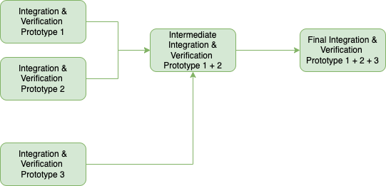

Usually the processes of integration, testing and validation are coupled together since they mostly use the same resources to arrive at conclusions. This helps in saving time and work while not compromising on the quality or performance.

1. ***Verification***

Verification for this particular system will consist of two phases. One alongside the integration phase to ensure the proper functioning of the components to provide the right output and the other phase will be done after integration of all the three major systems. The latter phase will concentrate more on the overall functionality of the system on a higher level. This will be done against the system requirements gathered in the earlier phases.All the TPM are given special attention during the verification phases.

The core of the verification process is the simulation and testing done right from the component level parts,the module, the subsystem and finally the full system. Some of these tests are automated while some others, especially ones concerning the safety and

security will require human resources. The main target here is to make sure all the functions are directly traceable to the requirements.

Apart from the rigorous hardware and repeated software tests, the control / communication system requires additional testing because:

* It involves physical outputs which cannot be afforded to go wrong as it involves safety factors.
* Any command read wrong due to any miscommunication could give unexpected results though most of the dangerous events are identified by the AI.
* The distinction between the types of command categories must be clearly defined so that only specific commands require admin access to operate.

All necessary tests to accomplish the above mentioned objectives are performed. Any new modes of failures, risks and anomalies are immediately discussed, solutions will be formatted accordingly and changes made will be recorded.

1. ***Transition***

Transition stage enables the deployment of the product from the production stage. This usually involves moving the product into its actual operational environment after all the necessary infrastructures and operational requirements are implemented including the operations & support service, maintenance schedule and trained personnel to administer the system.

Selection of the operational environment and the other necessary requirements will be based on the system specifications given along with the user requirements.

1. ***Validation***

Validation is the stage which is very much like verification but the system here is compared against the user and business needs or requirements. The project is said to be almost certainly successful once it meets the high level needs after verification of TPMs.

The initial process of this phase includes placing the system in an actual environment to check if it works as anticipated by the technical team while also satisfying the high level requirements. Activities like placing the robot in an actual house, checking its performance on the road, user voice identification in a crowded area, self-security from theft or malware attacks, reaction to unauthorized personnel interaction, Alarm system etc.

1. ***Operation***

The product can be transferred to the operational environment for utilization as soon as all the testing,verification and validation stages are over. All the actual characteristics and effects of the product are then checked to make sure they are operating within the required technical and non-technical constraints and norms.

All the performance metrics will be recorded and monitored by the admin to find any flaws during the utilization. Any process that needs assistance or admin access will be immediately addressed. The modes of failures and steps that can be taken to prevent it will be explained to the users beforehand.

1. ***Maintenance & Support***

Maintenance of this system can be in the form of preventive maintenance, corrective maintenance, condition-based maintenance or predictive maintenance inclusive of the regular service runs.

All maintenance schedules are formulated based on the simulation checks for hardware, software and control modules by estimating Mean Time Between Failure (MTBF), Mean Time To failure (MTTF), Mean Time Between Maintenance (MTBM) and Maintenance Down Time (MDT) etc.

The software or control system updates can be remotely done from distance which usually eliminates bugs and enhances firewall and security modules. It is recommended to keep the system in auto update mode so as to make the product’s update effective as soon as an improvement is done to the previous patch as the machine depends on the data and server to perform better with its neural engine.

All the maintenance checks and machine calibrations are done in the maintenance facility only once in every 3 months. Supporting staff will always monitor and oversee the status of the machine. Emergency roadside assistance will be provided on the spot within 1 to 2 hours of raising the ticket.

1. ***Disposal***

The disposal phase must account for the following components of the product:

* Software service that is to be decommissioned
* Hardware that is to be recycled or reused
* Communication channel that is to be severed
* Battery disposal
* Electronic components
* Material disposal including tyres and non usable body parts
* Engine fluids and lubricants
* And other related elements

The disposal is to be done according to the regulatory norms for each of these components as per the company and state guidelines for disposal. Deconstruction and removal of the critical parts must be done by a trained professional to ensure safety.

The risk factor associated with every component must be taken into account before disposal. Types of risk and the mitigation techniques used will vary from component to component with respect to its nature. Engine fluids or batteries containing different chemicals must be disposed of with utmost caution while the electronic components can be recycled or reused relatively easily; disposing the software must be done only after ensuring all the encrypted data is erased while a simple body material can be sent to the crushing factory etc. Therefore, a final study regarding the effect of disposal of every component on the environment must be done to ensure that the environment returns to its original state in the end.

______________________________________________________________________

End Of Project